**Application Details**

**Speed Trapper:**

1. The application is running under url <http://localhost/speedtrapper>.
2. The default Speed Limit is set to 200km/hr
3. There can be multiple instances of Speed-Trapper running at a time, so the Speed Limit changed in one instance is updated in other instances as well.
4. This snapshot shows the Cars running at the moment, their speed and their status (Running/Busted).

**Status: Running**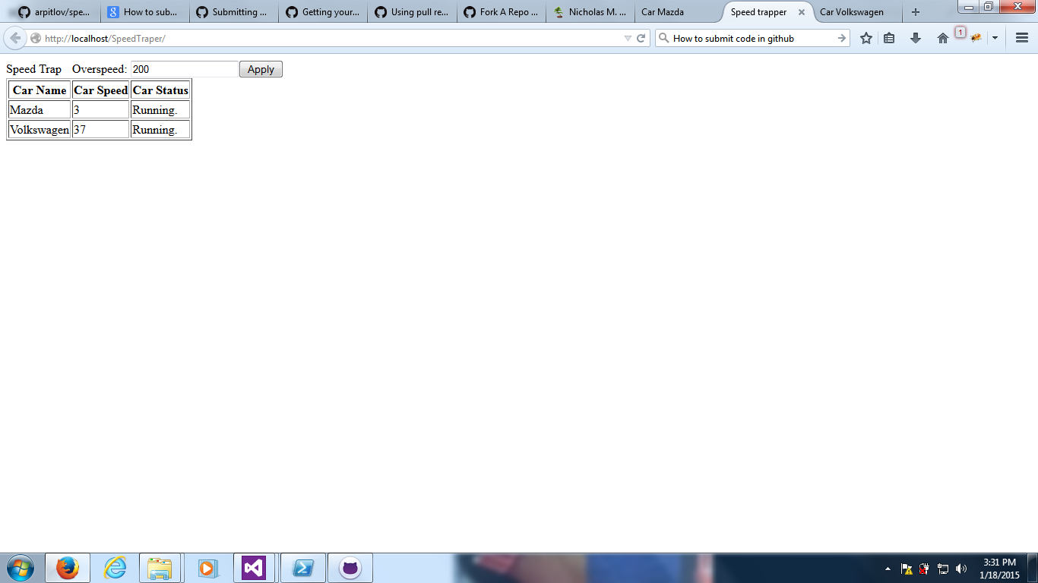

**Status: Busted**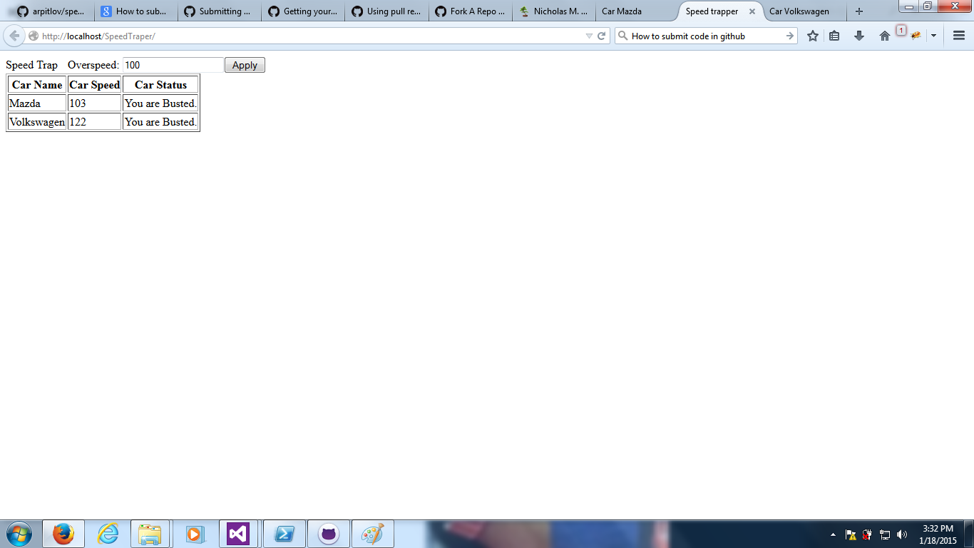

**Car:**

1. The application runs under url <http://localhost/car>
2. The speed of car changes after every 5 secs. The speed ranges between 0-200 km/kr.
3. The car names are maintained in a XML file “CarNames.xml” under Content folder. I have used Xml file so that it can be easily deserialized into list of string (Car names).
4. The snapshot below shows the Car app, Car name, its current speed and Speed limit if busted.
5. The app stops generating speed once busted.

